2024 • Volume • • Electronic publication date:

Australian Meningococcal Surveillance Programme Annual Report, 2023

Monica M Lahra, CR Robert George, Sebastiaan J van Hal and Tiffany R Hogan for the National Neisseria Network

# Abstract

In Australia, both probable and laboratory-confirmed cases of invasive meningococcal disease (IMD) are reported to the National Notifiable Diseases Surveillance System (NNDSS). When compared to 2022, the number of IMD notifications in 2023 increased by 14% to 143. Laboratory confirmation of IMD occurred in 140/143 (98%) of these cases, with 64% (90/140) diagnosed by bacterial culture and 36% (50/140) by nucleic acid amplification testing. The serogroup was determined for 96% of laboratory-confirmed cases (134/140): serogroup B (MenB) accounted for 84% of infections (112/134); MenW for 8% (11/134); MenY for 8% (11/134). There were no infections attributed to MenC disease. Fine typing was available on 75% of the cases for which the serogroup was determined (100/134). In MenB isolates, 25 *porA* types were detected, the most prevalent of which were P1.7-2,4 (32%; 26/82), P1.7,16-26 (16%; 13/82) and P1.22,14 (9%; 7/82). All eight typed MenW infections identified as *porA* type P1.5,2, with two different multi-locus sequence types (MLST) present: ST-11 (5) and ST-1287 (3) from the clonal complex 11, the hypervirulent strain reported in outbreaks in Australia and overseas. In MenY, the predominant *porA* type was P1.5-1,10-1 (90%; 9/10), ST-1655 and from clonal complex 23.

Peaks of IMD occurred in children aged less than 5 years and in those aged 15–24 years, accounting for 21% (30/140) and 26% (37/140) of laboratory-confirmed cases respectively. In children aged under 5 years, 93% of IMD (27/29) was MenB; in those aged 15–24 years, 100% of IMD (36/36) was MenB, with serogroup not determined for one case in each of these age groups. Of note, 14–15% of IMD occurred in each of the older age groups reported: adults 25–44 years (14%, 19/140), 45–64 years (14%, 20/140), and in those aged 65 years and older (15%, 21/140). Whilst MenB predominated in all age groups, the majority of MenY and MenW IMD cases were reported in adults aged 45 years and older.

All cultured IMD isolates (n = 90) had antimicrobial susceptibility testing performed. Minimum inhibitory concentration (MIC) values were reported using Clinical Laboratory Standards Institute (CLSI) interpretative criteria: 9% (8/90) were defined as penicillin resistant (MIC value: ≥ 0.5 mg/L); 71% (64/90) had intermediate susceptibility to penicillin (MIC values: 0.125 and 0.25 mg/L) and 20% (18/90) were susceptible to penicillin (MIC values: ≤ 0.064 mg/L). All isolates tested susceptible to ceftriaxone, ciprofloxacin and rifampicin.

Keywords: antimicrobial resistance; disease surveillance; invasive meningococcal disease; *Neisseria meningitidis*

# Introduction

Established in 1979, the National Neisseria Network (NNN) is a network of reference laboratories in each Australian state and territory that collaboratively undertakes laboratory surveillance of the pathogenic Neisseria species: *N. meningitidis* and *N. gonorrhoeae*. Since 1994, the NNN has coordinated laboratory data from cases of invasive meningococcal disease (IMD) for the Australian Meningococcal Surveillance Programme (AMSP), supported by the Australian Government Department of Health and Aged Care and the jurisdictions.1 The NNN laboratories supplement notification data from the National Notifiable Diseases Surveillance System (NNDSS), which includes cases of probable and laboratory-confirmed IMD.

Historically, IMD notifications in Australia peaked in 2002 at 3.5 cases per 100,000 persons per year,2 with the majority of disease caused by MenB and MenC.3 Following this, the introduction of the conjugate serogroup C meningococcal vaccine to the National Immunisation Program (NIP) in 2003 led to a significant and sustained reduction in serogroup C IMD notifications, and a reduction in overall notifications to a nadir of 0.6 cases per 100,000 persons in 2013.4,5 However, from 2013 an increase in both MenW and MenY IMD in Australia was reported, and the IMD notification rate increased to 1.5 cases per 100,000 in 2017,2 when MenACWY immunisation programmes were implemented across jurisdictions in targeted age groups. In 2018, the change from monovalent serogroup C to serogroup A, C, W and Y vaccination expanded coverage on the national immunisation programme for infants and then adolescents.3 Following the introduction nationally of the quadrivalent MenACWY vaccine in 2018, IMD notifications declined further from 1.1 per 100,000 in 2018 to 0.8 per 100,000 in 2019. In 2020, there were 0.4 cases per 100,000 recorded and a continued reduction was recorded in 2021, to 0.3 cases per 100,000 persons. This reduction in disease rate was beyond the expected vaccine impact and was likely attributable to the impact of public health measures implemented in response to the SARS-CoV-2 pandemic. In 2022, with the gradual easing of infection control containment measures, IMD notifications rose to 0.5 cases per 100,000 persons per year.

IMD is a rare disease in Australia but remains a public health concern; continued monitoring of phenotypic and genotypic features of IMD strains is critical to planning and informing clinical management of cases, case clusters and outbreaks of IMD locally and nationally, and to inform and monitor public health interventions.

# Methods

## Case confirmation of invasive meningococcal disease

Case confirmation is based on the culture of *N. meningitidis*, or molecular diagnoses from a normally sterile site, defined as laboratory-definitive evidence of IMD according to national case definitions.6 Information regarding the site of infection and the age and sex of the patients is collated by the NNN for the AMSP.

Invasive *N. meningitidis* infections are categorised according to the site of isolation, or the specimen type from which meningococcal DNA was detected (blood, joint fluid, and vitreous fluid). For a given patient, when *N. meningitidis* is detected from both blood and cerebrospinal fluid (CSF), it is classified as one of meningitis.

## Serogroup and genotyping of *Neisseria meningitidis*

Serogroup determination is performed through the detection of soluble polysaccharide antigens, with molecular testing playing an increasing role.7 Genotyping of both isolates and DNA extracts is performed by sequencing products derived from amplification of the *porA* gene. Multi-locus sequence typing (MLST) and clonal complex assignment are additionally reported by some jurisdictions.

## Antimicrobial susceptibility testing

Antimicrobial susceptibility testing (AST) of invasive meningococcal isolates is routinely conducted to support patient care. Testing is performed to determine the minimum inhibitory concentration (MIC) values for antibiotics used for treatment (ceftriaxone and penicillin), and for clearance of carriage (ciprofloxacin and rifampicin). In this report, antibiotic susceptibilities are reported according to the Clinical and Laboratory Standards Institute (CLSI) M100 guidelines;8 a change from historical reporting by the AMSP. By CLSI guidelines, MIC breakpoints are categorised as follows, for penicillin: susceptible (MIC values ≤ 0.064 mg/L); intermediate susceptibility (MIC values 0.125 and 0.25 mg/L); and resistant (MIC values ≥ 0.5 mg/L); for ceftriaxone: susceptible (MIC values ≤ 0.125 mg/L); for ciprofloxacin: susceptible (MIC values ≤ 0.032 mg/L), intermediate susceptibility (MIC value = 0.064 mg/L) and resistant (MIC values ≥ 0.125 mg/L); and for rifampicin: susceptible (MIC values ≤ 0.5 mg/L), intermediate susceptibility (MIC value = 1.0 mg/L) and resistant (MIC values ≥ 2 mg/L). Antimicrobial resistance to ciprofloxacin in *N. meningitidis* has been reportable to the national alert system for critical antimicrobial resistances (CARAlert) since January 2023.9

# Results

In 2023, there were 143 IMD cases notified to the NNDSS, of which 140 were laboratory confirmed.2 Laboratory data were available to the AMSP for all 140 laboratory-confirmed IMD cases, as shown in Figure 1. In 2023, an increase in the number of IMD notifications was observed across all jurisdictions bar one, most notably in Queensland, Victoria and South Australia. The exception was in Western Australia, where notification numbers were reduced by more than half, from 19 in 2022 to seven in 2023.10 In 2023, the peak incidence of IMD occurred in autumn through early winter (1 April to 30 June) and winter through early spring (1 July to 30 September), as shown in Table 1.

Figure 1: Number of invasive meningococcal disease cases reported to the National Notifiable Diseases Surveillance System, compared with laboratory-confirmed data from the Australian Meningococcal Surveillance Programme, Australia,a 1991–2023

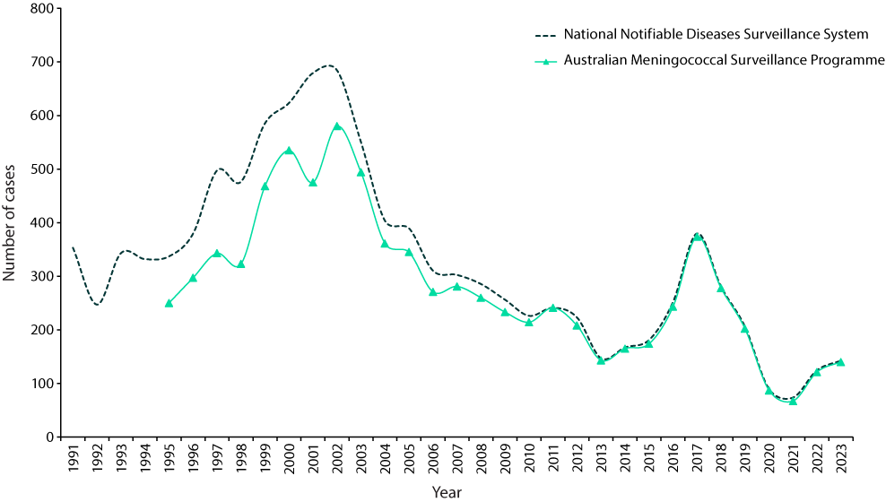

a Source: National Communicable Diseases Surveillance Dashboard. Data extracted 06 March 2024. https://nindss.health.gov.au/pbi-dashboard/.

Table 1: Laboratory-confirmed cases of invasive meningococcal disease, Australia, 2023 by quarter

| IMD serogroup | 1 January – 31 March | 1 April –  30 June | 1 July – 30 September | 1 October – 31 December | 2023 total |
| --- | --- | --- | --- | --- | --- |
| B | 24 | 34 | 29 | 25 | 112 |
| C | 0 | 0 | 0 | 0 | 0 |
| W | 1 | 3 | 5 | 2 | 11 |
| Y | 1 | 3 | 4 | 3 | 11 |
| NDa | 0 | 2 | 2 | 2 | 6 |
| Total | 26 | 42 | 40 | 32 | 140 |

a ND: not determined.

## Laboratory diagnosis of IMD

In 2023, laboratory diagnosis of IMD was conducted via culture in 64% of laboratory-confirmed cases (90/140) and by molecular testing (nucleic acid amplification testing) in 36% (50/140), as indicated in Table 2. There were 44 diagnoses of meningitis, 88 of bacteraemia, and eight derived from joint fluid aspirates.

Table 2: Number of laboratory-confirmed cases of invasive meningococcal disease, Australia, 2023, by specimen type and method of confirmation

| Specimen | Bacterial culture | Nucleic acid amplification test | Total |
| --- | --- | --- | --- |
| Blood | 73 | 15 | 88 |
| CSF ± blood | 13 | 31 | 44 |
| Joint aspirate | 4 | 4 | 8 |
| Total | 90 | 50 | 140 |

## Notifications by jurisdiction

Across the jurisdictions in 2023, Queensland reported the highest number of IMD notifications nationally (30%; 42/140), followed by New South Wales (25%, 35/140). For Queensland and New South Wales, although the numbers of IMD notifications exceeded those reported in 2022 (respectively 33/121 [27%] and 34/121 [28%]), the proportions were similar. From Victoria, there were 26 notifications in 2023 (2023: 19%, 26/140), increasing both in number and proportion from 2022 (2022: 12%, 15/121). In South Australia, IMD notifications rose in number from 14 in 2022 to 20 in 2023, but retained similar proportionality: 2022: 12%, 14/121; 2023: 14%, 20/140. The sole jurisdiction in Australia reporting a decline of IMD in 2023 was Western Australia, where notification numbers fell from nineteen in 2022 (16%, 19/121) to seven in 2023 (5%, 7/140). The number of IMD notifications from the Australian Capital Territory, Northern Territory and Tasmania remained low in 2023. Jurisdictional case numbers are shown in Table 3.

In 2023, MenB IMD was the most prevalent in Australia, accounting for 84% (112/134) of notifications (see Table 3), and similar to the 85% (100/117) reported in 2022 (see Figure 2), where the serogroup was determined. MenB IMD was reported across all age groups. Historically, from 2006 through 2014, the proportion of IMD attributable to MenB ranged from 74 to 84% nationwide, falling to 62% in 2015, and then 37% in 2016–2017. Subsequently, there has been an overall increase in the proportion of IMD attributable to MenB, rising to 44% in 2018, 50% in 2019, and 62% in 2020, with a temporally limited decrease to 52% observed in 2021.

Table 3: Number of laboratory-confirmed cases of invasive meningococcal disease, Australia, 2023, by jurisdiction and by serogroup

| Jurisdiction | Serogroup | | | | | |
| --- | --- | --- | --- | --- | --- | --- |
| B | C | W | Y | NDa | Total |
| Australian Capital Territory | 2 | 0 | 0 | 0 | 0 | 2 |
| New South Wales | 28 | 0 | 2 | 5 | 0 | 35 |
| Northern Territory | 1 | 0 | 2 | 0 | 0 | 3 |
| Queensland | 36 | 0 | 0 | 2 | 4 | 42 |
| South Australia | 16 | 0 | 3 | 1 | 0 | 20 |
| Tasmania | 3 | 0 | 1 | 0 | 1 | 5 |
| Victoria | 20 | 0 | 3 | 2 | 1 | 26 |
| Western Australia | 6 | 0 | 0 | 1 | 0 | 7 |
| Australia | 112 | 0 | 11 | 11 | 6 | 140 |
| % serogroup, where determined (n = 134) | 84 | 0 | 8 | 8 | — | % |

a ND: serogroup not determined.

In 2023, MenW and MenY each contributed to 8% (11/134) of IMD nationally (see Table 3). Since 2014, the rise in IMD notifications generally coincided with increases in numbers of infections of both MenW and MenY (see Figure 1 and Figure 2). Regarding MenW, this serogroup was responsible for a relatively low proportion of IMD cases prior to 2015, ranging within 1–5% during 2000–2012. Increases to 8–10% were observed in 2013–2014, to 21% in 2015, and a peak proportion of 44% observed in 2016. Subsequently, rates have progressively declined, from 36–38% in 2017–2018, to 18-26% in 2019-2021, then 4% in 2022 before increasing to 8% in 2023 (Figure 2). MenW disease was reported in small numbers across Australia: Victoria (3), South Australia (3), New South Wales (2), the Northern Territory (2) and Tasmania (1). Regarding MenY, the proportion of IMD cases attributable to this serogroup ranged within 1–5% in the years 2000–2010 before increasing to 6–11% from 2011–2014, 13% in 2015, 17% in 2016, and then 20% in 2017. The attributable proportion of MenY IMD ranged from 16% to 21% between 2018 and 2021, declining to 10% in 2022 and continued to lessen to 8% in 2023 (see Figure 2). In 2023, MenY disease in Australia was largely reported from New South Wales (5/35), accounting for 14% of jurisdictional notifications.

In 2023, no MenC IMD was reported from Australia. For IMD isolates where a serogroup could not be determined (6/140, 4%), this was due to insufficient DNA concentration available for nucleic acid amplification testing. Of note, there were very few cases of IMD reported from Tasmania (5), the Northern Territory (3) and the Australian Capital Territory (2).

Figure 2: Proportion of serogroups of laboratory-confirmed invasive meningococcal disease, Australia, 2000 – 2023 by year

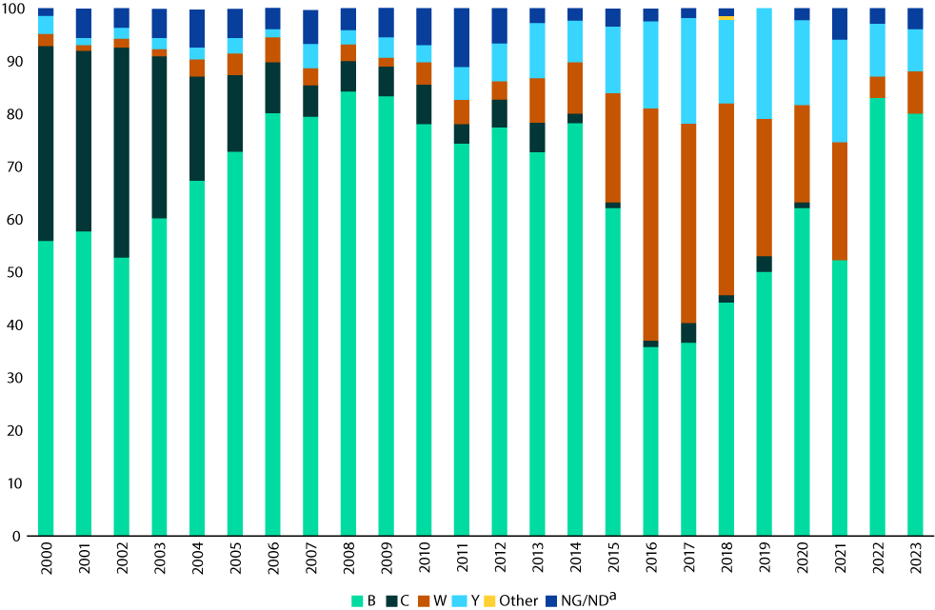

a NG/ND: non groupable/serogroup not determined.

## IMD age and serogroup distribution

In 2023, IMD notifications were reported in all age groups. Disease peaks occurred in children less than 5 years of age (30/140 cases; 21%), with 50% (15/30) of these children being aged less than one year. A second peak was observed in persons aged 15–24 years, which accounted for 26% (37/140) of laboratory-confirmed cases. The serogroup was determined for 134/140 cases of IMD (96%). In children aged under 5 years, 93% (27/29) of IMD was MenB, and in those aged 15–24 years, 100% (36/36) of IMD was MenB (where the serogroup was determined). Of note, 14–15% of IMD occurred in each of the older age groups reported: adults 25–44 years (14%, 19/140); 45-64 years (14%, 20/140); and those aged 65 years and older (15%, 21/140). While MenB predominated across all age groups, the majority of MenY and MenW IMD was reported in those over 45 years of age. No cases of MenC IMD were notified nationwide in 2023. The serogroup distribution for IMD nationally in 2023 is shown in Table 4 and Figure 3; MenB accounted for 84% (112/134) of IMD overall, and was the majority serogroup in all age groups. MenW and MenY IMD occurred sporadically in children aged less than 14 years, and was more commonly observed in adults aged 25 years and older.

Table 4: Laboratory-confirmed cases of invasive meningococcal disease (IMD), Australia, 2023, by age and serogroup, and the proportion of IMD attributable to MenB

| Serogroup | Age group (years) | | | | | | | | | Total |
| --- | --- | --- | --- | --- | --- | --- | --- | --- | --- | --- |
| < 1 | 1–4 | 5–9 | 10–14 | 15–19 | 20–24 | 25–44 | 45–64 | 65+ |
| B | 14 | 13 | 4 | 7 | 24 | 12 | 15 | 12 | 11 | 112 |
| C | 0 | 0 | 0 | 0 | 0 | 0 | 0 | 0 | 0 | 0 |
| W | 0 | 1 | 0 | 1 | 0 | 0 | 3 | 3 | 3 | 11 |
| Y | 0 | 1 | 0 | 0 | 0 | 0 | 1 | 3 | 6 | 11 |
| NDa | 1 | 0 | 1 | 0 | 1 | 0 | 0 | 2 | 1 | 6 |
| Total | 15 | 15 | 5 | 8 | 25 | 12 | 19 | 20 | 21 | 140 |
| % MenB IMD within age group (where a serogroup was determined) | 100% | 87% | 100% | 88% | 100% | 100% | 79% | 67% | 55% | 84% |

a ND: serogroup not determined.

Figure 3: Number of serogroup B, C, Y and W cases of laboratory-confirmed invasive meningococcal disease, Australia, 2023, by age

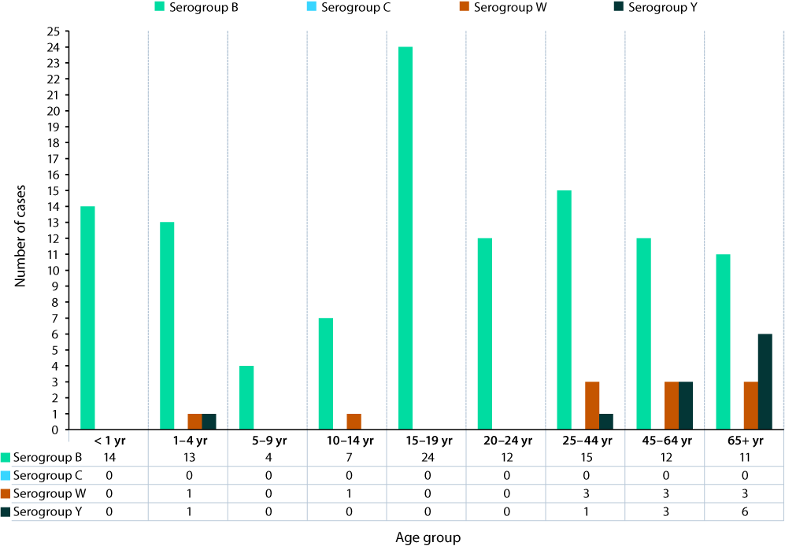

## IMD and genotyping

Finetyping was performed on 82 of 112 MenB IMD cases (73%) and this serogroup showed the greatest variability, with 25 *porA* types represented nationally; of these, three *porA* types predominated: P1.7-2,4 (26/82; 32%), P1.7,16-26 (13/82; 16%) and P1.22,14 (7/82; 9%), as shown in Figure 4 and Table 5. These were also the major *porA* types detected in 2022; however, in 2023, B:P1.7-2,4 was notably prevalent in South Australia (9/10) and Queensland (12/30), with these two jurisdictions together comprising 80% (21/26) of national isolates of this *porA* type.

The eight MenW IMD cases with typing data available (8/11) were of a single *porA* type, P1.5,2, all belonging to the ST-11 complex and with two different MLST sequence types determined: ST-11 (5) and ST-1287 (3) (see Figure 4 and Table 5). The *porA* type P1.5,2 has been the predominant genotype in recent years, from the clonal complex 11. This strain type is the same as the hypervirulent serogroup W strain reported in the United Kingdom and South America since 2009.11,12

Of the eleven MenY cases, ten had finetyping performed and two *porA* types were detected. The *porA* type, P1.5-1,10-1 was the most prevalent (9/10, 90%) (see Figure 4 and Table 5), identified as MLST ST-1655 and belonging to the clonal complex 23. The *porA* type P1.5-1,10-1 has remained the predominant MenY genotype circulating in Australia since 2014, marking the year when the increase in serogroup Y IMD was first observed.

Figure 4: The number of *porA* types represented in serogroup B, W and Y invasive meningococcal disease notifications in Australia in 2023

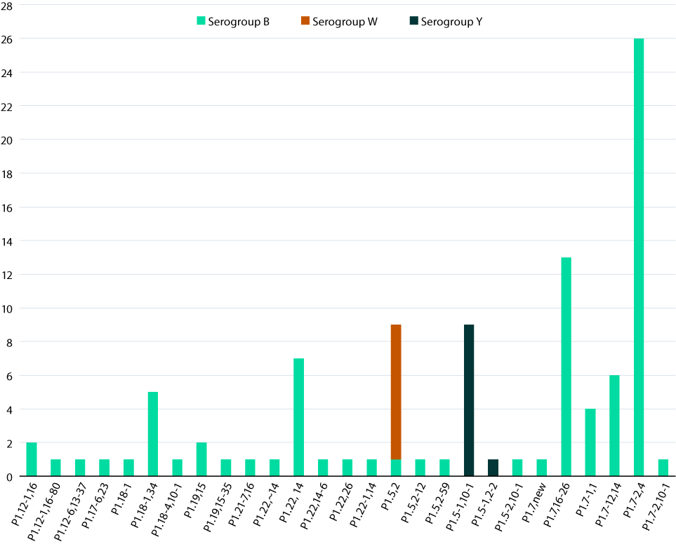

Table 5: Distribution of *porA* genotypes in typed isolates of invasive meningococcal disease, Australia, 2023, by state or territory (n = 100/140)

| 2023 AMSP | | Number per serogroup per state/territorya | | | | | | | | Total |
| --- | --- | --- | --- | --- | --- | --- | --- | --- | --- | --- |
| Serogroup | *porA* genotype | ACT | NSW | NT | Qld | SA | Tas. | Vic. | WA |
| B | P1.12-1,16 | 0 | 0 | 0 | 2 | 0 | 0 | 0 | 0 | **2** |
| B | P1.12-1,16-80 | 0 | 0 | 0 | 0 | 0 | 0 | 0 | 1 | **1** |
| B | P1.12-6,13-37 | 0 | 0 | 0 | 1 | 0 | 0 | 0 | 0 | **1** |
| B | P1.17-6,23 | 0 | 0 | 0 | 0 | 0 | 0 | 1 | 0 | **1** |
| B | P1.18-1 | 0 | 0 | 0 | 0 | 0 | 0 | 1 | 0 | **1** |
| B | P1.18-1,34 | 0 | 2 | 0 | 0 | 0 | 1 | 1 | 1 | **5** |
| B | P1.18-4,10-1 | 0 | 0 | 0 | 1 | 0 | 0 | 0 | 0 | **1** |
| B | P1.19,15 | 0 | 0 | 0 | 1 | 0 | 0 | 1 | 0 | **2** |
| B | P1.19,15-35 | 0 | 0 | 0 | 0 | 0 | 0 | 1 | 0 | **1** |
| B | P1.21-7,16 | 0 | 1 | 0 | 0 | 0 | 0 | 0 | 0 | **1** |
| B | P1.22, ~14 | 0 | 0 | 0 | 0 | 0 | 0 | 1 | 0 | **1** |
| B | P1.22, 14 | 0 | 2 | 0 | 4 | 0 | 0 | 1 | 0 | **7** |
| B | P1.22,14-6 | 0 | 0 | 0 | 0 | 0 | 0 | 1 | 0 | **1** |
| B | P1.22,26 | 0 | 0 | 0 | 1 | 0 | 0 | 0 | 0 | **1** |
| B | P1.22-1,14 | 0 | 1 | 0 | 0 | 0 | 0 | 0 | 0 | **1** |
| B | P1.5,2 | 0 | 1 | 0 | 0 | 0 | 0 | 0 | 0 | **1** |
| B | P1.5,2-12 | 0 | 0 | 0 | 1 | 0 | 0 | 0 | 0 | **1** |
| B | P1.5,2-59 | 0 | 0 | 0 | 0 | 0 | 0 | 1 | 0 | **1** |
| B | P1.5-2,10-1 | 0 | 0 | 0 | 0 | 0 | 0 | 1 | 0 | **1** |
| B | P1.7, new | 0 | 0 | 0 | 0 | 1 | 0 | 0 | 0 | **1** |
| B | P1.7,16-26 | 1 | 6 | 0 | 2 | 0 | 0 | 4 | 0 | **13** |
| B | P1.7-1,1 | 0 | 0 | 0 | 3 | 0 | 0 | 1 | 0 | **4** |
| B | P1.7-12,14 | 1 | 2 | 0 | 1 | 0 | 0 | 2 | 0 | **6** |
| B | P1.7-2,4 | 0 | 2 | 0 | 12 | 9 | 0 | 1 | 2 | **26** |
| B | P1.7-2,10-1 | 0 | 0 | 0 | 1 | 0 | 0 | 0 | 0 | **1** |
| W | P1.5,2 | 0 | 2 | 2 | 0 | 1 | 0 | 3 | 0 | **8** |
| Y | P1.5-1,2-2 | 0 | 1 | 0 | 0 | 0 | 0 | 0 | 0 | **1** |
| Y | P1.5-1,10-1 | 0 | 4 | 0 | 2 | 0 | 0 | 2 | 1 | **9** |
| Total |  | 2 | 24 | 2 | 32 | 11 | 1 | 23 | 5 | 100 |

a ACT: Australian Capital Territory; NSW: New South Wales; NT: Northern Territory; Qld: Queensland; SA: South Australia; Tas.: Tasmania; Vic.: Victoria; WA: Western Australia.

## Antimicrobial susceptibility testing

*Neisseria meningitidis* isolates are tested against currently recommended treatment (ceftriaxone and penicillin) and clearance antibiotics (rifampicin and ciprofloxacin). In 2023, national AST data are reported according to CLSI interpretative guidelines,8 changed from historical reporting (1997 to 2020). Of laboratory-confirmed IMD, 64% (90/140 isolates) had *N. meningitidis* cultures, permitting AST by NNN laboratories. Ceftriaxone AST was performed on all 90 isolates, all testing susceptible. The distribution of penicillin MIC values is shown in Table 6. Regarding penicillin, 20% of IMD isolates (18/90) tested susceptible (MIC values ≤ 0.064 mg/L); 71% (64/90) demonstrated intermediate susceptibility (MIC values 0.125–0.25 mg/L); and 9% (8/90) were resistant (MIC values ≥ 0.5 mg/L) (see Table 6). The proportion of penicillin-resistant isolates in 2023 was higher than reported in 2022 (5%, 3/62) (Figure 5). Of the isolates that tested penicillin resistant, there were four MenB and four MenW isolates. In recent years, MenW has demonstrated higher penicillin MIC values and higher proportions of resistance. In 2023, there was one resistant MenB isolated from Victoria with a penicillin MIC value of 1.0 mg/L, identified as *porA* type P1.7-1,1 and belonging to the ST-32 complex. Regarding the clearance antibiotics for IMD, 88 of the 90 isolates available for AST in 2023 were tested against ciprofloxacin and rifampicin; all were susceptible.

Table 6: Penicillin minimum inhibitory concentration (MIC) distribution of laboratory-confirmed invasive meningococcal disease isolates, Australia, 2023

| Penicillin MIC distribution | | | | | | | | | |
| --- | --- | --- | --- | --- | --- | --- | --- | --- | --- |
| MIC mg/L | 0.032 | 0.064 | 0.125 | 0.25 | 0.5 | 1 | 2 | ≥ 4 | Total |
| Number of isolates | 6 | 12 | 23 | 41 | 7 | 1 | 0 | 0 | **90** |
| % | 7% | 13% | 26% | 46% | 8% | 1% | 0% | 0% | **100%** |

Figure 5: Proportion of IMD isolates with susceptibility (S), intermediate susceptibility (I) and resistance (R) to penicillin,8 Australia in 2021 to 2023

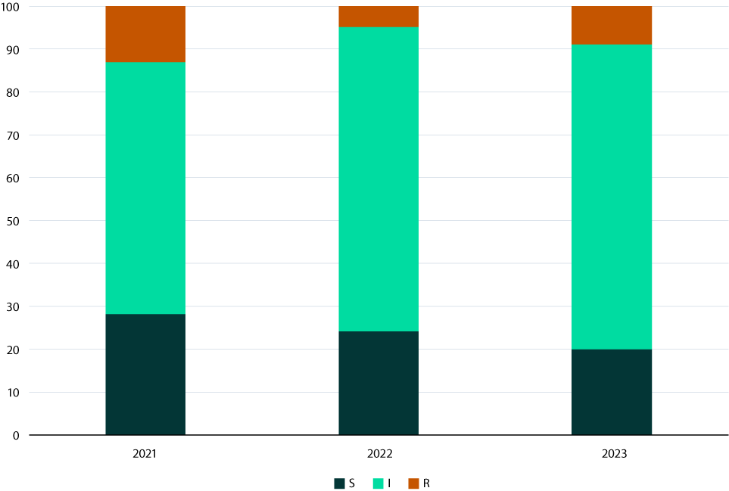

# Discussion

In 2023, there were 143 IMD notifications nationally, representing a 14% increase from the number reported in 2022. The IMD notification rate in Australia in 2021 was the lowest recorded since records began, coinciding with widespread public health initiatives designed to reduce coronavirus disease 2019 (COVID-19) transmission and with changes in the National Immunisation Programme (NIP) from a monovalent MenC to a quadrivalent MenACWY vaccine.13,14 In 2023, ninety-eight percent of IMD notifications in Australia (140/143) were laboratory-confirmed. The distribution of IMD notifications across jurisdictions in 2023 was proportionally similar to 2022, except in Victoria, where there was an increase from 12% to 18%; and in Western Australia, where there was a decrease from 16% to 5%.

The reports of the AMSP suggest that meningococcal vaccination programmes have had a sustained impact on the distribution of meningococcal serogroups in IMD.3 Following the introduction of the MenC vaccine in 2003, the proportion of MenB IMD was 84–88% in the years 2006–2012. From 2014, the emergence of MenW and MenY disease5,15 led to the replacement of the MenC vaccine at 12 months of age with a quadrivalent ACWY vaccine on the NIP in July 2018.14 A decrease in both notifications and the proportionality of MenW and MenY disease followed, accompanied by an increase in the proportion of MenB disease (from 44% to 62% in 2018–2021). In 2022, the number and proportion of IMD cases caused by MenB (100/117; 85%) were substantially greater than those reported in 2021 (35/67; 52%), with MenB IMD persisting at this level in 2023 (112/134, 84%).

In 2023, IMD notifications were reported in all age groups. Disease peaks occurred in children less than 5 years of age (30/140 cases; 21%); of these children, 50% (15/30) were infants aged less than one year. A second peak was observed in persons aged 15–24 years, accounting for 26% (37/140) of laboratory-confirmed cases. From 2018 to 2023, the proportion of all IMD in adolescents and young adults (i.e., those aged 15–24 years) doubled: from 13% of all IMD in 2018 (with MenB accounting for 58% of IMD in this age group) to 26% of all IMD in 2023 (with MenB accounting for 100% of IMD in this age group). This is similar to observations from the United Kingdom following easing of pandemic restrictions,16 where it was identified that the serogroup versus age distributions provide evidence that meningococcal vaccination programmes are maintaining low rates of MenC, MenW and MenY disease; however, low immunity against MenB, and high transmission of meningococci among adolescents and young adults, have resulted in increases in MenB disease, particularly in university students.16

Finetyping of MenB notifications in 2023 revealed the diversity of *porA* types in Australia (25 different *porA* types from the 82 investigations). The predominant MenB *porA* genotype in Australia was P1.7-2,4 (32%; 26/82), largely detected in South Australia and Queensland, followed by genotypes P1.7,16-26 (16%; 13/82) and P1.22,14 (9%; 7/82).

In 2023, MenW accounted for 8% of IMD notifications where a serogroup could be detected (11/134), which was a higher number and proportion than the 4% (5/117) reported in 2022. The proportion of IMD caused by MenW declined to 22% in 2021 from 38% in 2017. Of MenW notifications in 2023, there were isolated events in children aged 1–4 years and 10–14 years; this contrasts to 2021 where MenW comprised 50% (5/10) of IMD notifications in infants less than one year old. In 2023, MenW IMD mostly occurred in adults aged 25 years and older. The predominant circulating strain of MenW continues to be *porA* genotype P1.5,2, with MLST types belonging to clonal complex 11. This same MenW ST11 strain previously emerged in the United Kingdom (UK) and South America in 2009,11,12 and spread to account for 25% of IMD in the UK in 2014–2015 and 59% of all cases in Chile in 2012. MenW ST11 is hypervirulent and is associated with atypical clinical presentations, more severe disease, and a higher case fatality rate.12 The initial increase in MenW overseas and in Australia occurred in older adults but was subsequently reported across all age groups, particularly in adolescents and infants.15

In 2023, MenY accounted for 8% of IMD nationally (11/134), predominantly affecting those aged 45 years and over. MenY accounted for 17% of notifications with a serogroup determined (3/18) in individuals aged 45–64 years, and 30% (6/20) in individuals aged 65 years and older. Since 2014, the predominant MenY genotype continues to be P1.5-1,10-1, whereas previously MenY genotype distribution had been more heterogeneous.17

In 2023, an increased number of urogenital and anorectal infections with MenY ST-1466 were reported in NSW. Whole genome sequencing (WGS) found limited sequence diversity. Laboratory alerts regarding the outbreak were sent to all Australian jurisdictions through the NNN laboratories and two additional states (South Australia and Victoria) identified urogenital MenY ST-1466 infections detected in late 2023. Genomic analysis showed all MenY ST-1466 sequences were interspersed, indicative of a multijurisdictional outbreak.18 These infections continue to be reported. The incidence of urogenital meningococcal infections remains unknown, due to varied testing and reporting practices both within and across jurisdictions in Australia. Although sporadic cases of MenY urethritis have been previously reported,18 this is the first geo-temporal cluster of MenY urogenital disease documented.19

No MenY ST-1466 IMD has been recorded in Australia to the end of March 2024. However, concurrently in the United States of America (USA), an outbreak of MenY ST-1466 IMD has evolved. Very recently, an alert was raised by the US Government20 regarding the increase in number and proportion of MenY IMD in the USA, 68% of which was ST-1466, occurring in those aged 30–60 years (65%); in Black or African American people (63%); and in people with HIV (15%). The alert reports a case-fatality rate (CFR) of 18%, higher than the historical CFR of 11% reported for MenY IMD in 2017–2021 in the USA.

Antimicrobial susceptibility testing of IMD isolates in 2023 detected 9% (8/90) penicillin resistance (MIC values ≥ 0.5 mg/L) in clinical isolates. All IMD isolates tested in 2023 were susceptible to ceftriaxone, ciprofloxacin and rifampicin. It should be noted, however, that in the USA, the number of IMD cases caused by ciprofloxacin-resistant strains has increased since 2019 in some jurisdictions, requiring a change in recommendation of prophylactic agents in areas where ciprofloxacin resistance has been reported.21 In the USA, unlike Australia, susceptibility testing for *N. meningitidis* is not routinely conducted in support of patient care.21 Since January 2023, ciprofloxacin-resistant *N. meningitidis* has been notifiable to the National Alert System for Critical Antimicrobial Resistances (CARAlert), a component of the Antimicrobial Use and Resistance in Australia (AURA) surveillance system.9

In 2023, the key findings of the AMSP Annual Report are an overall increase in IMD nationally, the predominance of MenB disease, the doubling of IMD in adolescents and young people (all attributed to MenB) and an outbreak of urogenital MenY ST-1466 that coincides with an IMD outbreak with this same serogroup and ST in the USA. The NNN is continuing to lead further investigations in collaboration with the Australian Government Department of Health and Aged Care, closely monitoring the phenotypic and genotypic features of *N. meningitidis* causing IMD in Australia, including AMR. Additional investigations by the NNN, including whole genome sequencing of IMD isolates, are underway to enhance IMD surveillance in Australia. The AMSP data are utilised for informing treatment guidelines and disease prevention strategies, and to monitor the effects of interventions. The NNN is also leading investigations into the urogenital infections with MenY ST-1466 at a national level.

# Acknowledgments

Meningococcal isolates were received in the reference centres from many laboratories throughout Australia. The considerable time and effort involved in forwarding these isolates is recognised and these efforts are greatly appreciated. These data could not have been provided without this assistance and the help of clinical colleagues and public health personnel. The Australian Government Department of Health and Aged Care provided funding for the National Neisseria Network.

Members of the AMSP in 2023, to whom isolates and samples should be referred, and enquiries directed, are listed below.

**Australian Capital Territory**

K Kennedy, S Bradbury, C O’Brien, M McKeown.

Microbiology Department, The Canberra Hospital, Gilmore Crescent, Garran ACT 2605.

Telephone: +61 2 5124 2510.

Facsimile: +61 2 5124 4646.

Email: peter.collignon@act.gov.au

**New South Wales**

MM Lahra, EA Limnios, TR Hogan, RL Kundu.

Microbiology Department, New South Wales Health Pathology, The Prince of Wales Hospital, Barker Street, Randwick NSW 2031.

Telephone: +61 2 9382 3689.

Facsimile: +61 2 9382 3719.

Email: monica.lahra@health.nsw.gov.au

M Maley, R Porritt, K Thapa, Y Kwok.

Department of Microbiology and Infectious Diseases, New South Wales Health Pathology, Liverpool Hospital, Liverpool NSW 2170.

Telephone: +61 8738 5124.

Facsimile: +61 2 8738 5129.

Email: Robert.Porritt@health.nsw.gov.au

**Northern Territory**

R Baird, K Freeman.

Microbiology Department, Territory Pathology, Royal Darwin Hospital, Rocklands Drive. Tiwi NT 0810.

Telephone: +61 8 8922 8685.

Facsimile: +61 8 8922 7788.

Email: rob.baird@nt.gov.au

**Queensland**

S Schlebusch, R Graham, A Jennison.

Public Health Microbiology, Queensland Health Forensic and Scientific Services, 39 Kessels Road, Coopers Plains Qld 4108.

Telephone: +61 7 3096 2919.

Facsimile: +61 7 3096 2973, +61 7 3274 9175.

Email: Amy.Jennison@health.qld.gov.au

**South Australia**

M Warner, L Leong, M Hodgson.

SA Pathology, Royal Adelaide Hospital Site, Microbiology and Infectious Diseases, Royal Adelaide Hospital, North Terrace, Adelaide, SA 5000.

Telephone: +61 8 8222 3382.

Facsimile: +61 8 8222 3543.

Email: Lex.Leong@sa.gov.au

**Tasmania**

L Cooley, B McEwan.

Department of Microbiology and Infectious Diseases, Royal Hobart Hospital, 48 Liverpool Street, Hobart Tasmania 7000.

Telephone: +61 3 6166 8417.

Email: belinda.mcewan@ths.tas.gov.au

**Victoria**

B Howden, K Stevens, S. Tawil, P Roydhouse.

Microbiological Diagnostic Unit Public Health Laboratory, Department of Microbiology and Immunology, The Peter Doherty Institute, 792 Elizabeth Street, Melbourne, Victoria 3000.

Telephone: +61 3 8344 5713.

Facsimile: +61 3 8344. 7833.

Email: kerries@unimelb.edu.au

**Western Australia**

D Speers, R Ferdinand.

Department of Microbiology, QEII Medical Centre, PP Block Level 5, PathWest Laboratory Medicine, Hospital Avenue, Nedlands, WA 6009.

Telephone: 61 8 6383 4501.

Facsimile: +61 8 9382 8046.

Email: Rebecca.Ferdinand@health.wa.gov.au

# Author details

Monica M Lahra1,2

CR Robert George3

Sebastiaan van Hal4,5

Tiffany R Hogan1

1. World Health Organisation Collaborating Centre for STI and AMR, Sydney and Neisseria Reference Laboratory, Department of Microbiology, NSW Health Pathology, The Prince of Wales Hospital, Randwick, 2031, NSW Australia
2. School of Medical Sciences, Faculty of Medicine, The University of New South Wales, NSW, 2052 Australia
3. NSW Health Pathology, John Hunter Hospital, Newcastle, 2300, NSW Australia
4. New South Wales Health Pathology, Microbiology, Royal Prince Alfred Hospital Camperdown, NSW, Australia
5. School of Medicine, University of Sydney

**Corresponding author**

Professor Monica M Lahra

Director, Microbiology Department Neisseria Reference Laboratory and WHO Collaborating Centre for STI and AMR, NSW Health Pathology, Level 4, Campus Centre, The Prince of Wales Hospital, Randwick NSW, 2031

# References

1. National Neisseria Network. Meningococcal Isolate Surveillance Australia 1994. *Commun Dis Intell*. 1995;19(12):286–9.
2. Australian Government Department of Health and Aged Care. National Notifiable Diseases Surveillance System (NNDSS) data visualisation tool. [Webpage.] Canberra: Australian Government Department of Health and Aged Care; 14 December 2022. [Accessed on 5 February 2024.] Available from: https://www.health.gov.au/resources/apps-and-tools/national-notifiable-diseases-surveillance-system-nndss-data-visualisation-tool.
3. George CR, Booy R, Nissen MD, Lahra MM. The decline of invasive meningococcal disease and influenza in the time of COVID-19: the silver linings of the pandemic playbook. *Med J Aust*. 2022. doi: https://doi.org/10.5694/mja2.51463.
4. National Notifiable Diseases Surveillance System (NNDSS). Number of notifications of Meningococcal disease (invasive), received from State and Territory health authorities in the period of 1991 to 2012 and year-to-date notifications for 2014–2021. Available from: http://www9.health.gov.au/cda/source/rpt_4_sel.cfm.
5. Australian Government Department of Health and Aged Care. Invasive meningococcal disease. [Internet.] Canberra: Australian Government Department of Health and Aged Care; 12 July 2022. Available from: https://www.health.gov.au/internet/main/publishing.nsf/Content/ohp-meningococcal-W.htm.
6. Australian Government Department of Health and Aged Care, Communicable Diseases Network Australia (CDNA). *Invasive Meningococcal Disease: CDNA National Guidelines for Public Health Units*. Canberra: Australian Government Department of Health and Aged Care; 4 July 2017. Available from: https://www.health.gov.au/sites/default/files/documents/2020/02/invasive-meningococcal-disease-cdna-national-guidelines-for-public-health-units.pdf.
7. George CRR, Smith HV, Lahra MM. *Neisseria meningitidis*. In de Filippis I, ed. *Molecular Typing in Bacterial Infections*, Volume I. London: Springer International Publishing, Springer Cham, 2022;85–99.
8. Clinical and Laboratory Standards Institute (CLSI). Performance standards for antimicrobial susceptibility testing. 33rd ed. CLSI supplement M100. Wayne, PA: CLSI; 2023.
9. Australian Commission on Safety and Quality in Health Care (ACSQHC). National Alert System for Critical Antimicrobial Resistances (CARAlert). [Internet.] Sydney: ACSQHC; 23 Apr 2024. Available from: https://www.safetyandquality.gov.au/our-work/antimicrobial-resistance/antimicrobial-use-and-resistance-australia-aura/hospital-and-community-antimicrobial-resistance/national-alert-system-critical-antimicrobial-resistances-caralert.
10. Lahra MM, George CRR, van Hal SJ, Hogan TR for the National Neisseria Network. Australian Meningococcal Surveillance Programme Annual Report, 2022. *Commun Dis Intell (2018)*. 2023;47. doi: https://doi.org/10.33321/cdi.2022.47.44.
11. Abad R, López EL, Debbag R, Vázquez JA. Serogroup W meningococcal disease: global spread and current affect on the Southern Cone in Latin America. *Epidemiol Infect*. 2014;142(12):2461–70. doi: https://doi.org/10.1017/S0950268814001149.
12. Ladhani SN, Beebeejaun K, Lucidarme J, Campbell H, Gray S, Kaczmarski E et al. Increase in endemic *Neisseria meningitidis* capsular group W sequence type 11 complex associated with severe invasive disease in England and Wales. *Clin Infect Dis*. 2015;60(4):578–85. doi: https://doi.org/10.1093/cid/ciu881.
13. Chiu C, Dey A, Wang H, Menzies R, Deeks S, Mahajan D et al. Vaccine preventable diseases in Australia, 2005 to 2007. *Commun Dis Intell Q Rep*. 2010;34(Suppl):S1–167.
14. Australian Government Department of Health and Aged Care. Immunise Australia Program. Meningococcal Disease. [Internet.] Canberra: Australian Government Department of Health and Aged Care; 20 April 2015. Available from: https://www.health.gov.au/internet/immunise/publishing.nsf/Content/immunise-meningococcal.
15. Araya P, Fernández J, Del Canto F, Seoane M, Ibarz-Pavón AB, Barra G et al. *Neisseria meningitidis* ST-11 clonal complex, Chile 2012. *Emerg Infect Dis*. 2015;21(2):339–41. doi: https://doi.org/10.3201/eid2102.140746.
16. Clark S, Campbell H, Mensah AA, Lekshmi A, Walker A, Ribeiro S et al. An increase in group B invasive meningococcal disease among adolescents and young adults in England following easing of COVID-19 containment measures. [Online preprint.] Amsterdam: Elsevier, Social Science Research Network (SSRN); 8 January 2022. doi: https://doi.org/10.2139/ssrn.3998164.
17. Bröker M, Jacobsson S, Kuusi M, Pace D, Simões MJ, Skoczynska A et al. Meningococcal serogroup Y emergence in Europe: update 2011. *Hum Vaccin Immunother*. 2012;8(12):1907–11. doi: https://doi.org/10.4161/hv.21794.
18. Ladhani SN, Lucidarme J, Parikh SR, Campbell H, Borrow R, Ramsay ME. Meningococcal disease and sexual transmission: urogenital and anorectal infections and invasive disease due to *Neisseria meningitidis*. *Lancet*. 2020;395(10240):1865–77. doi: https://doi.org/10.1016/S0140-6736(20)30913-2.
19. Lahra MM, Latham NH, Templeton DJ, Read P, Carmody C, Ryder N et al. Investigation and response to an outbreak of *Neisseria meningitidis* serogroup Y ST-1466 urogenital infections, Australia. *Commun Dis Intell (2018)*. 2024;48. doi: https://doi.org/10.33321/cdi.2024.48.20.
20. Health Alert Network. Increase in invasive serogroup Y meningococcal disease in the United States. [Online health advisory.] Atlanta: United States Government Department of Health and Human Resources, Centers for Disease Control and Prevention (CDC), CDC Health Alert Network; 28 March 2024. [Accessed on 31 March 2024.] Available from: https://emergency.cdc.gov/han/2024/han00505.asp.
21. Berry I, Rubis AB, Howie RL, Sharma S, Marasini D, Marjuki H et al. Selection of antibiotics as prophylaxis for close contacts of patients with meningococcal disease in areas with ciprofloxacin resistance — United States, 2024. *MMWR Morb Mortal Wkly Rep*. 2024;73(5):99–103. doi: http://dx.doi.org/10.15585/mmwr.mm7305a2.

About Communicable Diseases Intelligence

Communicable Diseases Intelligence (CDI) is a peer-reviewed scientific journal published by the Health Security & Emergency Management Division, Department of Health and Aged Care. The journal aims to disseminate information on the epidemiology, surveillance, prevention and control of communicable diseases of relevance to Australia.

© Commonwealth of Australia as represented by the Department of Health and Aged Care

ISSN: 2209-6051 Online

This journal is indexed by Index Medicus and Medline.

This publication is licensed under a Creative Commons Attribution-NonCommercial-NoDerivatives 4.0 International Licence (CC BY-NC-ND) available from https://creativecommons.org/licenses/by-nc-nd/4.0/legalcode (Licence). You must read and understand the Licence before using any material from this publication.

Restrictions

The Licence does not cover, and there is no permission given for, use of any of the following material found in this publication (if any):

* the Commonwealth Coat of Arms (by way of information, the terms under which the Coat of Arms may be used can be found at www.pmc.gov.au/resources/commonwealth-coat-arms-information-and-guidelines);
* any logos (including the Department of Health and Aged Care’s logo) and trademarks;
* any photographs and images;
* any signatures; and
* any material belonging to third parties.

Disclaimer

Opinions expressed in *Communicable Diseases Intelligence* are those of the authors and not necessarily those of the Australian Government Department of Health and Aged Care or the Communicable Diseases Network Australia. Data may be subject to revision.

Enquiries

Enquiries regarding any other use of this publication should be addressed to the CDI Editor at: [cdi.editor@health.gov.au](mailto:cdi.editor@health.gov.au)

Communicable Diseases Network Australia

Communicable Diseases Intelligence contributes to the work of the Communicable Diseases Network Australia. www.health.gov.au/cdna

**Editor**: Christina Bareja • **Deputy Editor**: Simon Petrie • **Design and Production**: Lisa Thompson

**Editorial Advisory Board**: David Durrheim, Mark Ferson, Clare Huppatz, John Kaldor, Martyn Kirk and Meru Sheel

Contacts

CDI is produced by:

Health Security & Emergency Management Division, Australian Government Department of Health and Aged Care,  
GPO Box 9848, (MDP 6) CANBERRA ACT 2601

Website: [www.health.gov.au/cdi](http://www.health.gov.au/cdi)

Email: [cdi.editor@health.gov.au](mailto:cdi.editor@health.gov.au)

Submit an Article

You are invited to submit your next communicable disease related article to the *Communicable Diseases Intelligence* (CDI) for consideration. More information regarding CDI can be found at: www.health.gov.au/cdi.

Further enquiries should be directed to: [cdi.editor@health.gov.au](mailto:cdi.editor@health.gov.au)